100 Chart
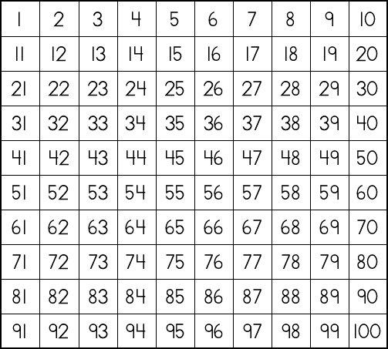
- Call a number and have your child color or cover it with a button, penny, or piece of candy or cereal.
- Have your child color all of the “10s”, or the “5s” and “10s”.
- Cover a number with something and have your child figure out what number is covered.
Name__________________________
You can print up more of these charts from the website: jkholstege.weebly.com on the page:
Things To Do With Your Child.

